Ref. No: Date: 04/01/2024.

Notice Regarding 5th Semester Programme Practical exam
It is hereby notify to all students of 5th semester programme that practical exam on CHEMGP DSE-1 will be held on 17/01/2024 as stated below. All students must come just 15 minutes before from the commencement time of exam at departmental practical room with their own admit card, Lab-coat, Practical Notebook, spatula, dropper etc. No excuse will be entertained.
Group A: Univ. Roll No: 2314137-2141735 to 2311137-2141799 (10:30 am to 12:30 pm).
Group B: Roll No: 2314137-2141800 to remaining all students & any candidate (6th sem) having supply in practical (1:15 pm to 3:15 pm).
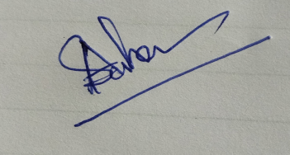
HOD
Department of Chemistry

